# Abstract

The coronavirus (COVID-19) is the most important health problems that has major threats to international public health. Covid-19 vaccines aim to protect from the infection and/or prevent clinical symptomatic disease and therefore reduce disease severity. They are being developed using various technologies. Covid-19. People living with different thought about the vaccine the current study aimed to analyse the statistical data that obtained from questionary scanning study to Iraqi society. The study focuses on how people behave towards coronavirus vaccines. In addition, the study emphasis on the reason behind accepted and refusing intake vaccination in both gender and dealing with features of coronavirus disease in different educational levels.

The current study started since June till Auges 189 cases collected. The highest percentage cases unvaccinated with Covid-19 vaccines is higher than the vaccinated 82%, while cases have got vaccine very low 17%. The results for the reason behind refusing vaccination illustrated that the greatest demand is for the percentage highly influenced by social media platforms However, the high percentage with family history to had infection. To conclude, Iraqi environment, misinformation and mistaken can succeed Health and organisations, academic institutions and the official responsible media have a responsibility and a challenge to clarify the importance of immunization and vaccination against this dangerous and rapidly spreading disease of Covid 19.

**Key words**: Covid-19, vaccine, coronavirus, Covid1-19 vaccine. Vaccine validity

# Introduction

Coronavirus disease (COVID-19) is the disease produced by 2019nCoV/SARS-CoV-2, a new β coronavirus of group 2B (1). The illness has different degrees ranges from mild infection to severe respiratory tract infections in humans similar to those type of severe acute respiratory syndrome (SARS) and Middle East respiratory syndrome (MERS). It has several symptoms include fever, coughing, dyspnea, watery diarrhea, myalgia, severe lymphopenia, prolonged coagulation profiles, cardiac disease, and unexpected death (2) .

Quantitative real-time polymerase chain reaction (RT-PCR) is the fundamentally tool to diagnosis of Covid-19 based on testing SARS-CoV-2 RNA. Nevertheless, the nucleic acid testing results are focus to many factors, firstly, the sample position, type, value, and patients’ illness, and sample storage. In some individuals with COVID-19 could not be diagnosis if the diagnosis is based solely on the viral RNA load. For this reason, on March 3, 2020, SARS-CoV-2-specific IgM and IgG antibody levels detection were added to the diagnosis and treatment protocol for coronavirus as substitute procedures to diagnose the suspected patients (3). Antibody detection is considered as easier, consider, rapid test and simpler to store than viral RNA load testing. Therefore, antibody tests can provide a significant complementary procedure for detecting of COVID-19 (4).

In Iraq the first COVID-19 case was informed on 24 February 2020. After that, Iraqi cities began to register and confirm new COVID -19 infections with a wide diversities of proportions cases number (5). Three important medical examination laboratories centres were opened Iraqi provinces for COVID-19 testing in three main cities, Najaf, Bashar, and Baghdad medical city (6).

As shown in figure 1 the daily number of Iraqi Covid-19 cases in between February 2020 till August of 2021. The number of cases increasing in July and reached to highest record since the Covid-19 entered Iraq in 2020 (6). The Ministry of Health definite a total of 32,822new cases week representing a 10% increase as compared with the previous week. Also, the new Covid-19 associated deaths reported recently, were 180 with 7,7%.

The new strain of Covid-19 B.1.617.2 (delta) which appear in India initially. It shows a modified of the severe acute respiratory syndrome coronavirus 2(SARSCoV-2), and the virus (Covid-19) has contributed to a new endemic complicated cases in India and has now been diffusion across the whole world, including a notable increase in cases in the Britain.

In order to prevent further spread of Covid-19, and to develop efficient and safe drugs and vaccines which develop in a vital approach to drop the disease incidence and death rates. The long effective vaccines can be more cost-effective and therefore can have a convincing impact on the world, as the confirmed successfully other past endemic such as smallpox and polio vaccines (7). Vaccines often suffer from underinvestment, however that has not been the case in this pandemic (8) . Since of Feb 3, 2021, A number of vaccines had sequential development. Only five of these vaccines—those developed by AstraZeneca in partnership with Oxford University, BioNTech in partnership with Pfizer, Gamaleya, Moderna, and Sinopharm in partnership with the Beijing Table 1(8, 9).

All vaccines undergo for phases before are conducted and distributed to whole world. In order to determine dosages and identify any potential side effects in a small number of people the vaccine start with phase 1 testing. Then, phase 2 trials further determine safety and start to investigate efficacy on bigger groups. Phase 3 trials, which few vaccines ever make it to, are much larger, involving thousands or tens of thousands of people, to authorise and evaluate the effectiveness of the vaccine and test whether there are any few side effects that only show up in large groups. Finally, phase 4 trials, is directed after national controlling agreement and involves further intensive care in a wide population over a specific time as a form of post-marketing supervision [8]. Nevertheless, not all vaccines that have been approved for domestic are in phase 4 trials this is depend on Regulators their own individual procedures. For instance, in Russia and China, began approving vaccines for (limited or widespread) public use even before phase 3 trials were completed (10, 11). The important types of Covid-19 Pfizer vaccine. Third type of vaccine inactivated SARS-CoV-2 vaccine for example Sinopharm produced in China in institute of Biological Products (9, 11). As the world health organisation statistical analysis in Iraq, they found that 20 June 2021, a total of 825,051 vaccine doses were administered Iraq wide indicating that

3.57% of the target population received at least one dose of the COVID-19 vaccine.

Inoculation data, so far, revealed the administration of 396.993doses of Astrazeneca, 234.400 of the Pfizer, and 193.658 of the third country certified Sinopharm vaccine. Our study, aimed to illustrated how the Iraqi people deal with Covid-19 vaccination which we thought that may be related to elevated percentage beside the difficult controlling how people protect themselves and controlling the causes factors that increasing the percentage infected cases of corona. Furthermore, our study tried to support these people how took the vaccine and elucidate to the people who do not trust the vaccine

**Table 1:** Some of Candidate vaccines of Covid-19.

|  |  |  |
| --- | --- | --- |
| **Type of candidate vaccine** | **Vaccine platform description** | Sinovac Research and Development Co., Ltd |
| 1 | Inactivated virus | CoronaVac; inactivated SARS-CoV-2 vaccine (Vero cell) |
| 2 | Inactivated virus | Inactivated SARS-CoV-2 vaccine (Vero cell) |
| 3 | Viral vector (Non-replicating) | **AstraZeneca + University of Oxford** |
| 4 | Viral vector (non-replicating) | Recombinant novel coronavirus vaccine (Adenovirus type 5 vector) |
| 5 | RNA based vaccine | Pfizer/BioNTech + Fosun Pharma |

**Figure1:**

COVID

-

19

Vaccines in clincal developments phases

(14).

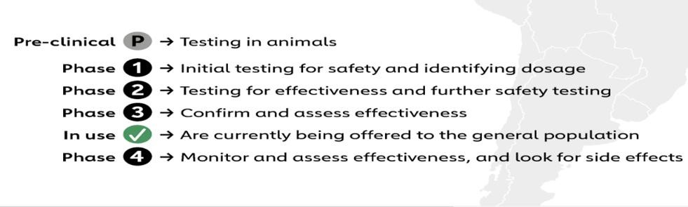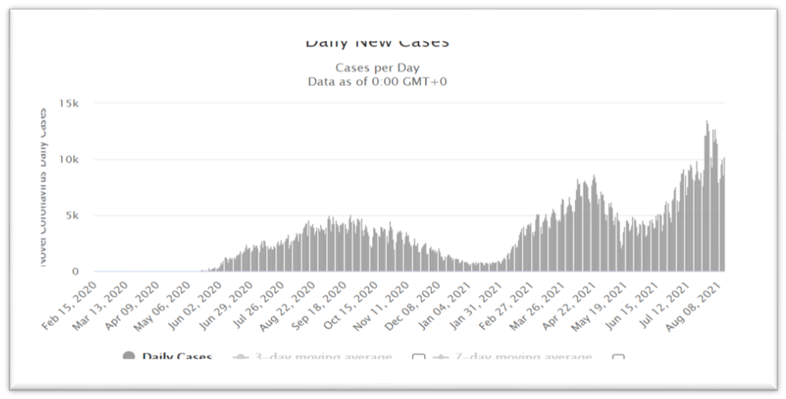

**Figure 1** Daily New cases of Covid-19 in Iraq since February 2020 till August 2021 (WHO).

We need to answer the question what is the mean reason behind the rejection of Iraqi people to take Corona virus vaccine?

## Methods

189 cases are collected and questionary form was designed asking about age gender previous infection and the vaccination if done or not and asking about the reason for their refutation to take the Covid-1 9 vaccine. Statistical analysis was done by prism.

**Results and discussion**

# Statistical analysis of cases of sample

## Age and COVID-19

Three age groups divided cases aged 10-30 had the highest percentage in the cases sample 59% as can see figure2 . The second highest group were those between the ages of 10-30 making 34% of the population.

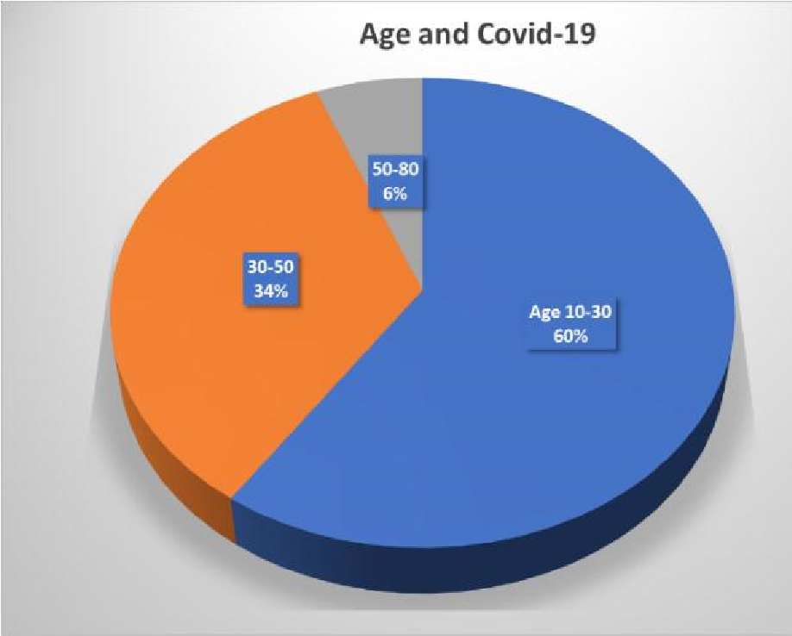Age 10-30 59

30-50 34 50-80 6

**Figure 2:** Collected cases of 189 patients divided three age groups. the highest number with corona virus in the age group of 10-30 years old.

## Vaccinated cases

% 31 of the cases did not vaccinated, while 17% have got vaccine very low vaccinated percent as showed in figure 3 a and be my related to the low educated with the significant role to the vaccine to prevent Covid-19 infection.

|  |  |  |
| --- | --- | --- |
| **vaccinated** | **Count vaccinated** | **of** |

**No** 156

# Yes 32

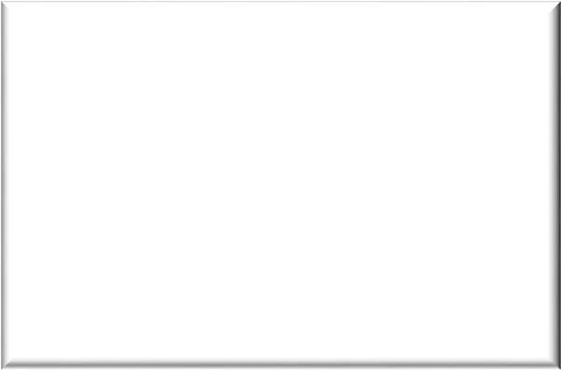

0

50

100

150

200

No

Yes

**B**

**Count of vaccinated and**

**unvaccinated cases**

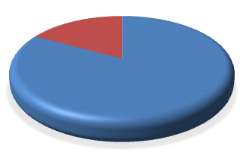

**No**

**83**

**%**

**Yes**

**17**

**%**

**A**



No



Yes

**Figure :3** Count of vaccinated and unvaccinated cases with highest percentage of unvaccinated cases.

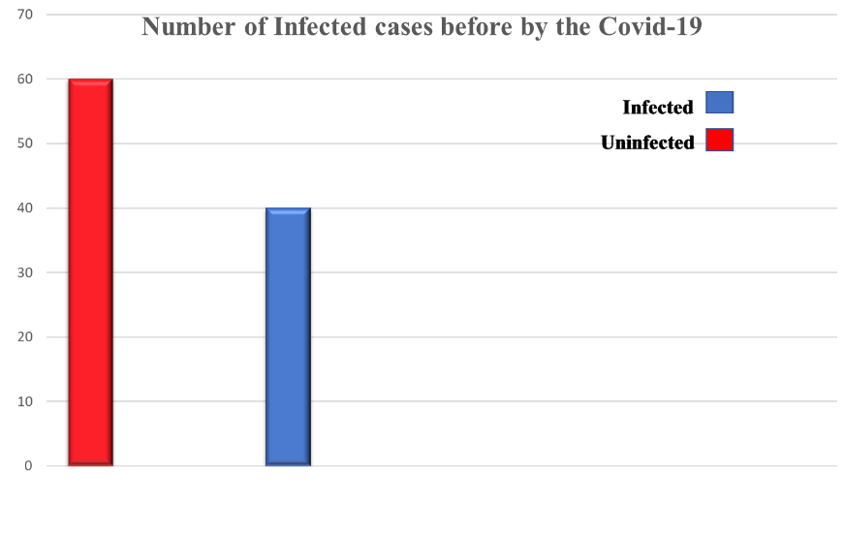

**Figure 4:** Percentage cases had infection with Covid-19 in the study sample.

In the other hand 36% of participants had Covid-19, whereas the other 64% weren’t infected before. The explanation of this result related to the previous findings. Because, the highest percentage is the youngest age group 10-30 they are basically have active immune system and resistance defense make their body strong enough against Covid-19 that make the percentage of infection is lower. Also, there is an important reason the high restricted rules for the government helping to lowest the infection(12). But this is can be change in any time depends on the new wave of COVID-19 and also the possibility the government restriction can be change according to the economically crisis of the general people in Iraqi society makes the infection percentage very easy to drop that what happen latter(12).

## Reasons for refusing vaccine intake

In spite of the new waves of Covid-19 also the high-risk possibility to diffuse this dangerous infectious disease, The results obtained from the preliminary analysis for the reason behind refusing vaccination illustrated that the greatest demand is for the percentage highly influenced by social media platforms 35% by watching videos on Facebook, WhatsApp and watching some TV that impact dramatically to their decision to refuse getting vaccine. Interestingly, the rumor and fake or advice of friends reached 30% influenced on refusing to vaccinate. While 13% have got vaccine and others 22% they do not answer and they are all did not get vaccine. This result reflects the negatively effect of different types of social media and negative rumor of Iraqi society according the cases responses. In addition, the weakness effect of the high education and medical staff and they do not have them enough area to show their attitudes towards the important of Covid-19 vaccination.

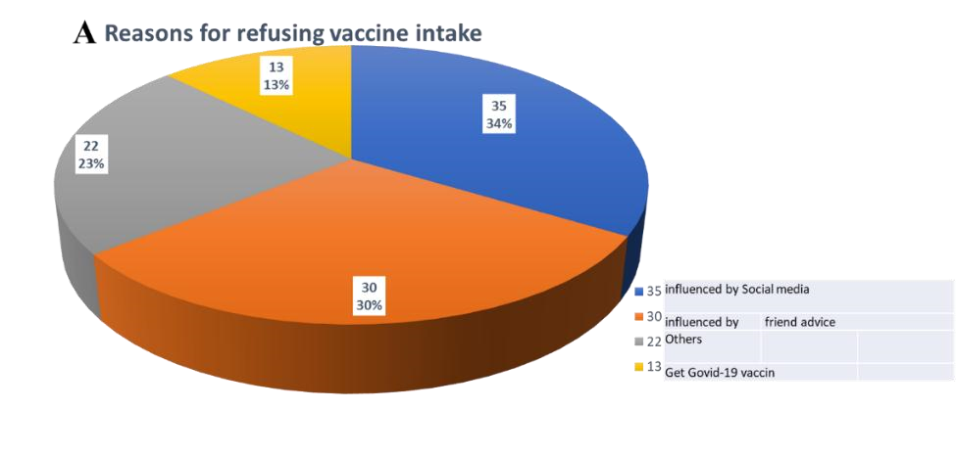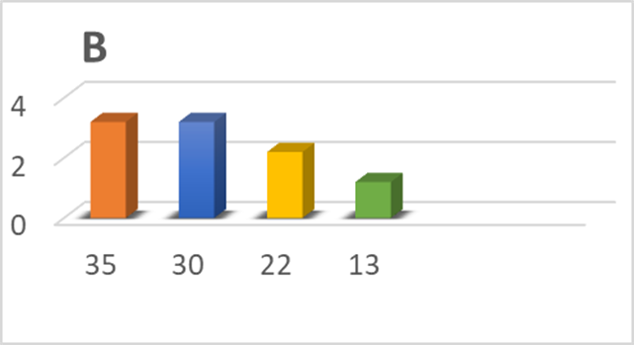

**Figure 5:** Reasons types behind refusing Covid-19 vaccines intakeA,B.

**Table: 3** Reasons types behind rfusing and low percentage vaccine intake.

|  |  |
| --- | --- |
| Reason | Numbers of |
| Influenced by Social media(Whatsab, facebook, TV) | 35% |
| Advised by friend | 30% |
| Get Govid-19 vaccin | 13% |
| others | 22% |

As a result for the influenced of social media and they confuse the importance and the aurthresation of vaccination as they undergow process of identifying appropriate antigens and delivery systems for SARA-CoV-2 vaccineis ongoing and candidate vaccines are being evaluated inexperimental animal models and human clinical trials before human being use (9, 11, 13). People in socity they do not have any background that make them to trust the vaccine as well as the negativelly impact of unresponsiballity media the make 47% dosen’t truast the vaccine and 35% hesitate and others may be intake vaccine 18% or they still they do not have about the vaccine(14).

|  |  |
| --- | --- |
| **59**  **%**    **23**  **%**    **10**  **%**    **8**  **%**    **(**  **A)**  **People attitudes towards Covid**  **-**  **19**  **vaccine**    dos'not trust vaccine  Histatae  vaccinated  others |  |
| **(B) People attitudes towards Covid-19 vaccine**  50  45    35    13    7    40  30  20  10  0 **dos'not Histatae vaccinated others trust vaccine** | |

**Figure 6:** People attitudes towards Covid-19 vaccineA, B.

In spite of the high percentage of members their family infected 57.7% with Covid19 as can see in figure 7 while 42.3 had no cases most the cases sample did not get vaccine that means people still do not understand the significant dengerous of the disese and the vaccine how is necessary to keep them selfs in safe(11). This declare different problems. Firstlly, the Shortening governmental and educational and medical staff to elevate and educate the community and highlight the scientific and importance of vaccination to combat infection with the Corona virus, as well as reduce the severity of the infection. Secondelly, the Covid-19 vaccine is an infectious new disease and pass throw different variations to infected people in different conditions make peoople still confusing and they do not get their descion easly espacially under the negative influence of social media that come during the same time with first time Covid-19 vaccine enter to Iraqi hospitals and medical centers.

As can ss in figure 7 and table 81.5% had no deaths in their family because and 18.5% had cases of death from COVID-19.



0

20

40

60

80

100

120

No

Yes

**Count of Are there any family infections?**

**Figure 7:** Number of cases had Covid-19 infection in cases sample.

|  |  |
| --- | --- |
| **Family Covid-19 history infection?** | **Numbers** |

No 80

Yes 108

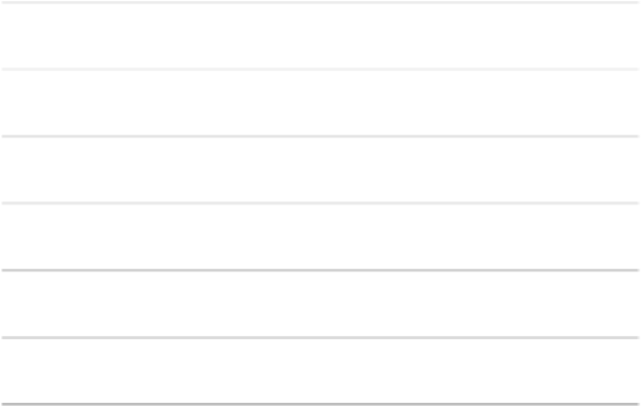

0

20

40

60

80

100

120

140

**Number of cases**

**times infected with covid**

**Times of infected with Covid**

**-**

**19**

infected twice

once infected

uninfected

**Figure 8:** Times of infections of Covid-19 in cases sample

|  |  |
| --- | --- |
| **Times infected** | **with** |
| **Covid-19** | **Cases Numbers** |

Infected twice 10

Infected once 20

Uninfected

## Conclusions

Although, the great achievement made by the most important advanced research and medical centres in the field of global medicine to produce the Corona vaccine that nearly eliminate the severe respiratory infection Covid-19. However, Covid-19 infection still in complected situation in Iraqi population, according to the WHO recent statistical analysis showed raising in percentage and diffusion in the society.

Because they face a different challenge related to unclear regarding to the importance of corona virus vaccines and the percentage of unvaccinated cases is higher than the vaccinated people. In this type of environment, misinformation and mistaken conjectures can succeed. Nearly the common social media like WhatsApp and Facebook had an opinion piece or something downplaying the significant of taking vaccine of this virus meanwhile most countries in the world start to roll out from this endemic. Iraqi medical and academic staff face a huge challenge to clarify the vaccination important and beside the official media.